**Raspberry pi based weather reporting IoT**

**A Project Report**

Submitted in partial fulfilment of the

Requirements for the award of the Degree of

**BACHELOR OF SCIENCE (INFORMATION TECHNOLOGY)**

**By**

**Shivbahadur vishwakarma**

Seat Number: 44

And

**Satyam Tiwari**

Seat Number: 41

**Under the esteemed guidance of**

**Mrs. Sneha Gokarnkar**



**DEPARTMENT OF INFORMATION TECHNOLOGY**

**Laxmi Charitable Trust’s**

**SHETH L.U.J. & SIR M.V. COLLEGE OF ARTS, SCIENCE & COMMERCE**

**(*Affiliated to University of Mumbai*)**

**Dr. S Radhakrishnan Marg, Andheri (E), Mumbai – 400 069.**

**MAHARASHTRA**

**2021-2022**

**CERTIFICATE**



This is to certify that the project entitled, " **Raspberry Pi Based Weather Reporting Over IOT**", is bonafied work of **SHIV BAHADUR VISHWAKARMA** bearing **Seat. No:44 and** **SATYAM TIWARI** bearing **Seat. No:41** submitted in partial fulfillment of the requirements for the award of degree of BACHELOR OF SCIENCE in INFORMATION TECHNOLOGY from University of Mumbai.

**Internal Guide** **Coordinator**

**External Examiner**

**Date: College Seal**

**ABSTRACT**

Weather condition plays a very important role in our daily life. Collecting of data about the different parameters of the weather is necessary for planning in home and environments. Recent developments in Internet of Things made possible to collect the data.

This project represents the real time monitoring and updating weather conditions over the internet. The system monitors three parameters namely temperature, humidity and raindrop. These values are then displayed on LCD. When the area is dry it shows zero value. When the system detects raindrop, it shows the value of the increase in raindrop. When the temperature increases the value gets updated. The user can observe the weather status of a particular area from any remote location. For this purpose, we have used Raspberry Pi 4 board. Raspbarian operating system is selected to use with Linux Kernel for Raspberry Pi 4. Python Language is used for programming because IDLE understands Python. By readings, the user can get a fair idea of the weather of a particular area on the monitor. This system proves to be useful for knowing the weather of the localized area.

In this Project we have research of the latest IoT which key enabling technologies, major IoT applications in industries and identifies research trends and challenges. A main contribution of this project is that it summarizes the current state-of-the-art of IoT in industries systematically. The advancement of Automation technology, life is getting simpler and easier in all aspects. In today’s world Automatic systems are being preferred over manual system. With the rapid increase in the number of users of internet over the past decade has made Internet a part and parcel of life, and IoT is the latest and emerging internet technology. Internet of things is a growing network of everyday object-from industrial machine to consumer goods that can share information and complete tasks while you are busy with other activities. This paper proposes that the industrial monitoring by using Temperature sensor, Rain Drop Sensor and Humidity Sensor, values to read the value and monitoring using Thing speak system via Raspberry pi 4.

**ACKNOWLEDGEMENT**

This project could not have been accomplished if not for the direct or indirect contribution from many known and unknown individuals. I wish to take this opportunity to express my sincere gratitude to all of them.

I express my gratitude to my internal guide Mrs. Sneha Gokarnkar who gave me unending support from the stage the project was initiated. A source of inspiration, given by her constantly kept our spirits high, whenever i was dispirited.

I would also like to thank our H.O.D Mrs. Sneha Gokarnkar as well as our principal Mrs. jyoti Gaitonde the foundation that I have been able to develop today owes much credit to them. Always ready to co-operate, they has been very kind in guiding us how to go about developing the Successful Project.

I would even like to thank my college SHETH L.U.J & SIR M.V. COLLEGE OF ARTS, SCIENCE & COMMERCE and all respected teaschers and family. Above all i would like to thank first, the almighty who have given me inspiration and courage to accept it's a course of life.

**DECLARATION**

I hereby declare that the project entitled, “**Raspberry Pi Based Weather Reporting Over IOT**” done at place where the project is done, has not been in any case duplicated to submit to any other university for the award of any degree. To the best of my knowledge other than me, no one has submitted to any other university. The project is done in partial fulfillment of the requirements for the award of degree of **BACHELOR OF SCIENCE (INFORMATION TECHNOLOGY**) tobe submitted as final semester project as part of our curriculum.

**Name and Signature of the Student**

Shiv Bahadur Vishwakarma

&

Satyam Tiwari

Table of Contents

Table of Contents 6

Chapter 1 7

Introduction 7

1.1 Background- 8

1.2 Objective- 9

1.3 Purpose - 9

1.4 Achievements – 10

Chapter-2 11

SURVEY OF TECHNOLOGIES 11

Chapter 3: 12

Requirements and Analysis 12

3.1 Problem Definition: – 12

3.2 Requirements Specification – 12

3.2.1 Hardware Components Specification - 12

3.2.2 Software Component Specification - 19

3.3 Planning and Scheduling- 21

3.4 Software and Hardware Requirements- 22

3.5 Preliminary Product Description – 22

3.6 Conceptual Models – 23

CHAPTER 4 24

SYSTEM DESIGN 24

4.1 Basic Modules – 24

4.2 Data Design – 25

4.3 Procedural Design – 28

4.4 User interface Design – 29

4.5 Test Cases Design – 32

Chapter 1

Introduction

Weather or Climate is important part of human life. Sensors are essential components not only applicable to the industries for process control but also in daily life for safety of building’s and traffic flow measuring,

environmental parameters measurement. In weather monitoring, factors such as temperature, humidity and rain drop to be measured for this project, thus sensors have always been given the task for doing so. Main focus of project is to develop compact and powerful weather station. Data acquisition systems are very popular for consumer and industrial applications. The proposed system has three sensors that measures different parameters as stated above & for rain fall detection and wind direction speed measurement weather instrument is included. Raspberry Pi 4, acting as data logger process the converted output of sensors from analog to digital. The logged data can then be transferred to a desktop or any other monitor has GUI for further analysis. So by using easily obtained components and less complicated circuitry powerful weather station can be built Now a day’s various weather factors like wind and many other cause great impact on human’s day to day life. In raspberry pi based weather monitoring system which depends on combination of several sensors to be integrated has been proposed. Raspberry Pi will receive readings from various sensors and then process the data and then data will be available on cloud server for viewing of user at remote location Weather Monitoring can be done in either wireless or wired manner. The Raspberry is cheap, small and rugged which make it perfect for real world projects? For agricultural development and industrial management, the proposed system is useful.

1.1 Background-

Humidity, Temperature and Pressure are three basic parameters to build any Weather Station and to measure environmental conditions. This IoT based Project aims to show the current Humidity, Temperature and Pressure parameters on the LCD as well on the Internet server using Raspberry Pi, which makes it a Raspberry Pi Weather Station. You can install this setup anywhere and can monitor the weather conditions of that place from anywhere in the world over the internet, it will not only show the current data but can also show the past values in the form of Graphs.

We have used DHT11 Humidity & temperature sensor for sensing the temperature and BM180 Pressure sensor module for measuring barometric pressure. This Celsius Scale Thermometer and percentage scale Humidity meter displays the ambient temperature and humidity through a LCD display and barometric pressure is displayed in millibar or hPa (hectopascal). All this data is sent to server for live monitoring from anywhere in the world over internet.

This IoT based project has four sections. Firstly, DHT11 sensor senses the Humidity & Temperature Data and BM180 sensor measures the atmospheric pressure. Secondly Raspberry Pi reads the DHT11 sensor module’s output by using single wire protocol and BM180 pressure sensor’s output by using I2C protocol and extracts both sensors values into a suitable number in percentage (humidity), Celsius scale (temperature), hectoPascal or millibar (pressure). Thirdly, these values are sent to server by using inbuilt Wi-Fi of Raspberry Pi 3. And finally server analyses the data and shows it in a Graph form. A LCD is also used to display these values locally.

Server will provide very good tool for IoT based projects. By using server & website, we can monitor our data and control our system over the Internet, using the Channels and webpages provided by webserver. webserver will ‘Collects’ the data from the sensors, ‘Analyze and Visualize’ the data and ‘Acts’ by triggering a reaction.

We have to define some fields for the data as we want to monitor, like in this project we will create three fields for Humidity, Temperature and Pressure data.

1.2 Objective-

The AIM of this research is to design a cost effective, flexible and portable weather Reporting over IoT that will be used to measure and monitor temperature, humidity and rain drop dew point temperature altitude.

The Objectives of the research work are to -

1) Design the circuit using Raspberry Pi 4 with some modern reliable sensors and other components -

2) Write the code using Python3 programming language on the raspbrian os.

3) Use the system to log in weather data to ensure that the device measures weather data periodically and log the data to database.

4) Approximate all the temperature data and analyze for the forecasting.

5) Compare the readings from the weather monitoring system with those from the Center for atmospheric Research (CAR) and online weather report (Accu Weather Report).

1.3 Purpose -

The purpose of this system is very wide. Internet of Things is just opening its arms, Same system can be applicable to the variety of applications like Data of Weather reporting, sending and controlling of data at remote location. In this project I have used sensors with digital input but with suitable humidity, raindrop sensor convertor we can easily use sensors with analog input. As applications are literally limitless through Raspberry Pi. Thus, such a system can be readily implemented using a low cost computer like Raspberry Pi which can function like a complete computer. Using moisture sensor Automatic irrigation control can be done in order to get information about field Data can be monitored using sensors Surveillance system.

**Scope -**

The scope is important to set a boundary on what the area will cover in the project. Thus Weather Station using Internet of Things is focused on getting data about weather like temperature, humidity, and pressure.

1. **User -** Can view the data of temperature, humidity and wind speed.
2. **System –**

* Collects whether data from whether station.
* Save the real time data and sent the data to local server.

**Applicability –**

This system can be applicable to the variety of applications like controlling of data at remote location. IOT based meteorological station can act as the input to the systems which can be applied in smart farming, industrial developments, educational purpose, energy sectors, food industries, marines etc. The .csv file generated has multiple records of the all the parameter sensed. It can serve as the historical data for supervised machine learning.

1.4 Achievements­­ –

This IOT weather reporting system could be installed in that industrial and commercial building where temperature and humidity values are so much important such cooling stores, chemicals store and vegetables stores etc.

This system also gives the alarming beep it user when temperature or humidity level increased by the set values.

This system is less costly, more efficient and more precise as compared to other systems.

Chapter-2

SURVEY OF TECHNOLOGIES

Through the meteorological system, we can collect data on humidity and Temperature, as well as data on pollution and, taking into account current and previous data, we can graphically modify the results in any system.

After reviewing many articles, there are currently far fewer articles that mention weather reporting the combination of temperature and humidity senser in a small integrated system and have actuators to change these settings.

There is a research paper that discussed the monitoring of these three environmental conditions; however, there was no mention of having actuators to modify. Thus, the main idea was to create a system that could detect the main components that make up the climate and be able to predict time without human error. Existing weather forecasting methods were generally based on observed patterns of events, and can be called pattern recognition. For example, one could observe that if the sunset was red and normal, the next day often brought a very nice weather. This experience gathers more than and generations to produce the tradition of the time.

However, not all of these predictions are reliable and since then many of them have not been able to withstand rigorous statistical testing. The simplest way to predict time, persistence, depends on today's conditions to predict tomorrow's conditions. This can be a good way to predict weather when it is in a stationary state, such as during the summer in the topics. This method of forecasting depends on the presence of a stationary weather pattern. It can be useful for both short- and long-range weather forecasts. Pressure measurements and pressure variations over time have been used in forecasts since the 19th century.

Chapter 3:

Requirements and Analysis

3.1 Problem Definition: –

Human activity is influenced by weather conditions, monitoring of weather conditions can help in controlling the activity. It is important to monitor and study the pattern of weather at surrounding. Limited way for user to know about weather such as temperature, humidity and rain drop. Without weather station, user can’t be alerted of the strong winds, heat waves or any other weather-related emergency. Furthermore, difficulty in making weather forecasts without data. When user use weather station, user can view the history of information as well. User can figure out the trends in the measurements. This will allow user to analyze the trends in a more effective way.

3.2 Requirements Specification –

The components needed for this project, i.e., IOT Live Weather Reporting Using Raspberry Pi4 are given below. All these components can be purchased from online or Electronic Shop.

3.2.1 Hardware Components Specification -

* **Raspberry Pi4 –**

Raspberry PI is a card-sized ARM powered Linux computer development board. There are in total of 5 types of various board with different specification, for the proposed Weather forecasting system Raspberry PI 2 model B is used as the main development board which is shown in Figure1

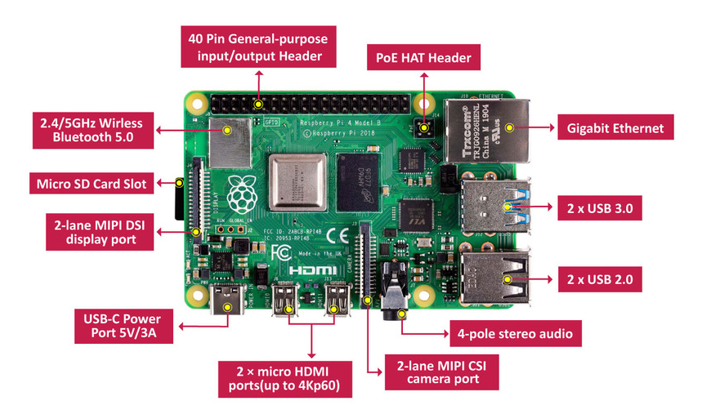

The raspberry pi consists of four USB Ports and one 10/100 Base T Ethernet Socket. Forty pins GPIO Header are present in the raspberry pi board which is used for connecting to Analog to Digital converter chip (MCP3008) to which the sensors are connected. A 5V Micro USB power port is present to which the power supply is given for the device. A HDMI port is present through which interfacing of the monitor and the Raspberry pi can be done and the USB ports for the keyboard and mouse interfacing. At the bottom a Micro SD Card Slot is provided where the Micro SD card is to be inserted with the Raspbian Jessie botting software which based on the Linux platform. The GPIO pins have different uses individually such as power supply, ground, clock, UAR.

* SoC Broadcom BCM2711, quad-core Cortex-A72 (ARM v8) 64-bit at 1.5GHz
* SDRAM 4 GB LPDDR4-2400
* Wireless LAN 2.4 GHz and 5.0 GHz IEEE 802.11b/g/n/ac, Bluetooth 5.0, BLE
* True Gigabit Ethernet
* 2 USB 3.0 ports, 2 USB 2.0 ports
* Fully backward compatible 40-pin GPIO connector
* 2 HDMI micro ports supporting video resolution up to 4K 60Hz
* 2-way MIPI DSI DSI/CSI ports for camera and display
* Stereo audio output and composite video port, 4-pole
* Slot for Micro SD card, for operating system and data storage
* Requires 5.1V, 3A power supply via USB-C or GPIO
* PoE (Power over Ethernet) enabled (requires PoE HAT)
* **DHT11 Digital Temperature Humidity Sensor –**

DH11- It consists of a humidity sensing component, a NTC temperature sensor (or thermistor) and an IC on the back side of the sensor. The humidity sensing component has two electrodes with moisture holding substrate between them. So as the humidity changes, the conductivity of the substrate changes or the resistance between these electrodes changes which are measured and processed by the IC and humidity value is calculated. As the temperature increases the NTC thermistor resistance decreases resulting the increase in the output voltage which then processed by the IC and the temperature value is calculated.

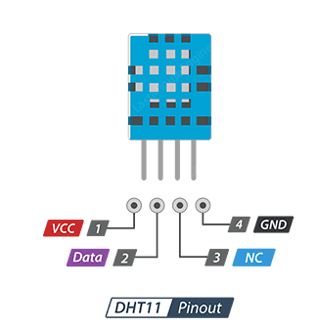

***VCC***  - pin supplies power for the sensor. Although supply voltage ranges from 3.3V to 5.5V, 5V supply is recommended. In case of 5V power supply, you can keep the sensor as long as 20 meters. However, with 3.3V supply voltage, cable length shall not be greater than 1 meter. Otherwise, the line voltage drop will lead to errors in measurement.

***Data*** pin is used to communication between the sensor and the microcontroller.

***NC*** Not connected.

***GND*** should be connected to the ground of Arduino.

* **Rain Drop Sensor –**

Rain Sensor- The rain sensor module is an easy tool for rain detection. It can be used as a switch when raindrop falls through the raining board and also for measuring rainfall intensity. The module features, a rain board and the control board attached for more convenience, power indicator LED The analog output is used in detection of drops in the amount of rainfall. Connected to 3.3V/5V power supply and the sensor works based on the level of the water interfacing the rain board, the output voltage of the device various on the length of the rain board being wet which is converted to digital through ADC chip.

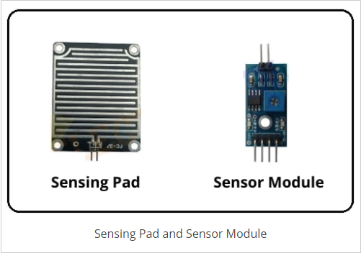

* **Sensing Pad -**

The Rain Sensor Module’s Sensing Pad consists of two nickel-coated series copper tracks. Also, it has two Header pins, these are internally connected to the two copper tracks of the Sensing Pad. These pins are used to connect the Sensing Pad to the rain sensor module circuit through two jumper wire. Always, one pin of the rain sensor circuit provides a +5v power supply to the one track of the sensing pad, and another pin is received the return power supply from another track of the sensing pad.

Normally under dry conditions, the sensing pad provides high resistance and low conductive. So, the 5v power supply cannot be passed from one track to another track. Its resistance varies according to the amount of water on the surface of the sensing pad. When water drops fall on the sensor pad surface its resistance will decrease and conductivity will increase. So, when water drops increase on the pad surface it can pass more power supply through one track to another track.

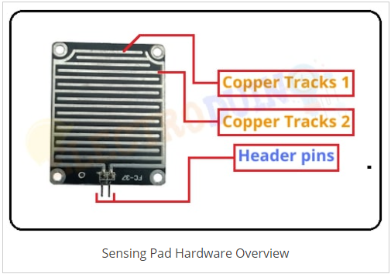

* **Sensor Module –**

The Sensor module is consisting of some key components. These are LM393 Comparators, Variable Resistor (Trim pot), Power LED, output LED.

* **Variable Resistor (Trimmer)**

This rain sensor module circuit has an onboard Trim pot or variable resistor(potentiometer), which is a 10k preset. It is used to set the sensitivity of the rain sensor, rotate the preset knob to adjust the sensitivity of the rain detection. If the preset knob rotated clockwise, the rain sensor sensitivity will be increased. If it rotated counterclockwise, the rain sensor sensitivity will be decreased.

* **Power LED**

This LED indicates the sensor power supply is ON or OFF. When we turn on the sensor power supply this RED LED is also turn ON.

* **Output LED**

When the rain sensor detects the rainfall or water drops, the RED LED is turn on. When it does not detect any rainfall or water drops, the RED LED is turn off.

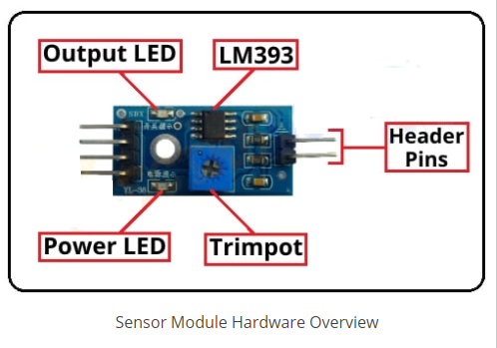

* **How Rain Sensor Module Works -**

At first, we need to connect the Sensing Pad to the Sensor Module through the jumper wire. Now we can connect the rain sensor module’s Vcc & Gnd pin to 5v power supply. Then set the threshold voltage at the Non-Inverting input (3) of the IC in dry condition of the sensing pad by rotating the potentiometer knob to set the sensitivity of the sensor.

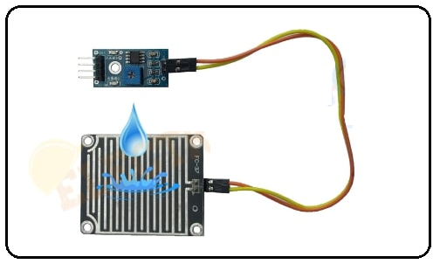

When water drops increase on the sensing pad surface then its conductivity will increase and also resistance will decrease. Then a Low amount of voltage from the sensing pad is given to the Inverting input (2) of the IC. Then the LM393 IC compares this voltage with the threshold voltage. In this condition, this input voltage is less than the threshold voltage, so the sensor output goes LOW (0).

When no water drops fall on the sensing pad surface then it has low conductivity and high resistance. Then the high amount of voltage will be allocated across the sensing pad. So, a High amount of voltage from the sensing pad is given to the Inverting input (2) of the IC. Again the LM393 IC compares this voltage with the threshold voltage. In this condition, this input voltage is greater than the threshold voltage, so the sensor module output goes High (1).

3.2.2 Software Component Specification -

* **Raspbian**

Raspbian is a Debian-based computer operating system for Raspberry Pi. Since 2015 till now it is officially provided by the Raspberry Pi Foundation as the primary operating system for the family of Raspberry Pi single-board computers.

Raspbian is free and open-source software. Raspbian operating system is based on Linux kernel. An SD card is used to install an operating system.

Raspbian was created by Mike Thompson and Peter Green as an independent project.

The initial build was completed in June 2012.The operating system is still under active development. Raspbian is highly optimized for the Raspberry Pi line's low-performance ARM CPUs.

Raspbian uses PIXEL, Pi Improved Windows Environment, Lightweight as its main desktop environment as of the latest update. It is composed of a modified LXDE desktop environment and the Open box stacking window manager with a new theme and few other changes. The distribution is shipped with a copy of computer algebra program Mathematical and a version of Mine craft called Mine craft Pi as well as a lightweight version of Chromium as of the latest version.

Raspbian is a free operating system based on Debian optimized for the Raspberry Pi hardware. An operating system is the set of basic programs and utilities that make

your Raspberry Pi run. However, Raspbian provides more than a pure OS: it comes with over 35,000 packages, precompiled software bundled in a nice format for easy

installation on your Raspberry Pi.

The initial build of over 35,000 Raspbian packages, optimized for best performance on the Raspberry Pi, was completed in June of 2012. However, Raspbian is still under active development with an emphasis on improving the stability and performance of as many Debian packages as possible

**Developer Raspberry Pi Foundation**

• OS family: Unix-like

• Source model: Open source

• Latest release: Raspbian Jessie with PIXEL / 16.02.2017

• Marketing target: Raspberry Pi

• Update method: APT

• Package manager: dpkg

• Platforms: ARM

• Kernel type: Monolithic

• Userland: GNU

• Default user interface: PIXEL, LXDE

• License: Free and open-source software licenses (mainly

GPL)

* **Python**

Python is used for general purpose programming which is free to use and high-level language. Python is a interpreted, interactive, object-oriented and beginner’s language. Python can runs on Linux kernel. IDLE (Integrated Development and Learning Environment) is the special text editor software used for programming in python.

* **HTTP**

REST (Representational State Transfer protocol) is a scalable architecture that allows things to communicate over Hyper Text Transfer Protocol and is easily adaptable for IoT applications to provide a communication from things to a central web server. Interoperability between computer systems on the internet is provided by the web services like REST or RESTful. Web service is a service offered via World Wide Web by an electronic device to another electronic device, communicating with each other. In that web technology such as HTTP was originally designed for human to machine communication and now utilized for machine-to-machine communication. HTTP (Hyper Text Transfer Protocol) is an application protocol used for data communication for the World Wide Web. HTTP is the protocol which is used to exchange or transfer hypertext. HTTP functions as request-response protocol in the client-server computing model. Here client is a web browser and application running on the computer or system is a server. In this system Raspberry Pi itself act as a server. HTTP request is sent by the client to the server. Then response message is sent by the server to the client. In the response completion status of request and requested content is sent.

3.3 Planning and Scheduling-

Using a Gantt Chart that describes key of activities and timescales involves in implementing this project as shown in Table 1



**Pert Chart –**

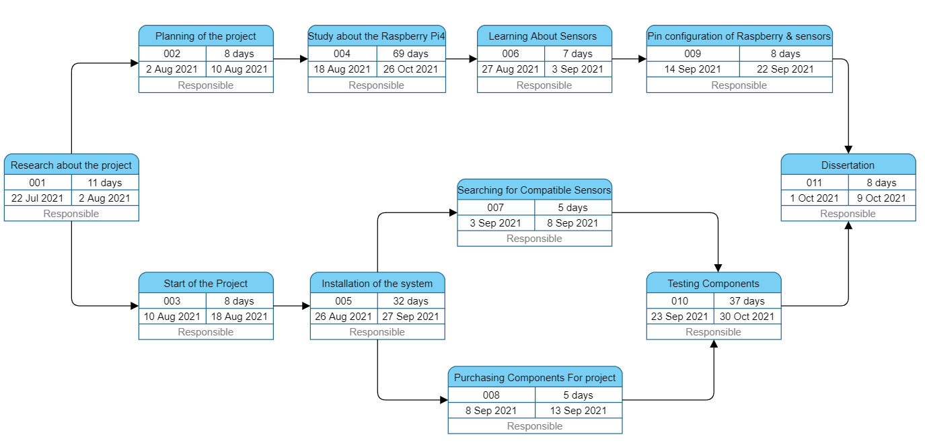

3.4 Software and Hardware Requirements-

**Hardware Requirements**

* Raspberry Pi4
* DHT11 Digital Temperature/Humidity Sensor
* Rain Drop Sensors
* LCD Display
* Resistors,
* Capacitors
* Transistors and Diodes
* PCB and Breadboards

**Software Requirements –**

* + OS Linux
  + Python

3.5 Preliminary Product Description –

In IOT enabled weather reporting project, Raspberry pi measures 3 parameters using respective 3 sensors. These sensors are temperature sensor, humidity sensor and raindrop sensor. These 3 sensors are directly connected to Raspberry pi since it has an inbuilt Analog to digital converter. Raspberry pi calculates and displays these weather parameters on an LCD display. Then it sends these parameters to the Internet using IOT techniques. The process of sending data to the internet using Wi-Fi is repeated after constant time intervals. Then the user needs to visit a particular website to view this data. The project connects and stores the data on a web server. Thus the user gets Live reporting of weather conditions. Internet connectivity or Internet connection with Wi-Fi is compulsory in this IOT weather reporting.

3.6 Conceptual Models –

**Block Diagram: -**

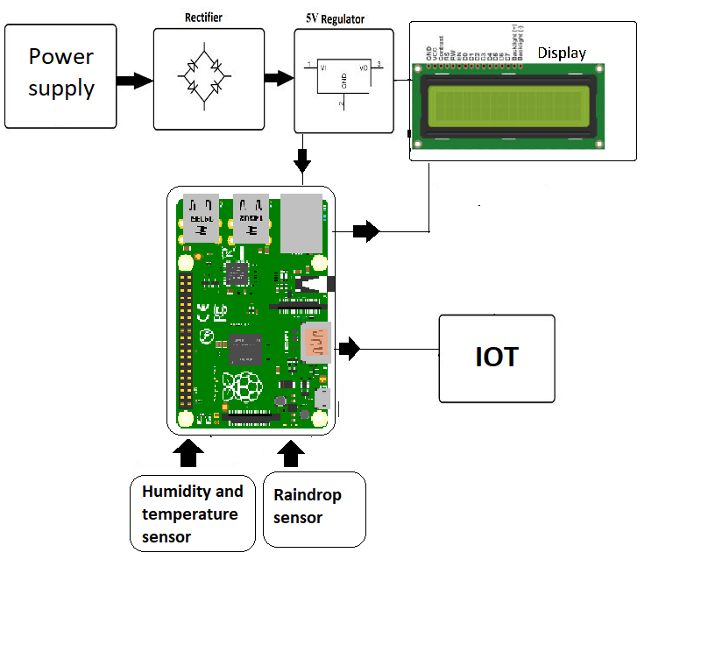

CHAPTER 4

SYSTEM DESIGN

4.1 Basic Modules –

Humidity, Temperature and Pressure are three basic parameters to build any Weather reporting and to measure environmental conditions. We have previously built a mini Weather reporting using raspberry pi and this time we are extending the weather reporting with Raspberry Pi. This IoT based Project aims to show the current Humidity, Temperature and raindrop parameters on the LCD as well on the Internet server using Raspberry Pi, which makes it a Raspberry Pi Weather report. You can install this setup anywhere and can monitor the weather conditions of that place from anywhere in the world over the internet, it will not only show the current data but can also show the past values in the form of Graphs.

4.2 Data Design –

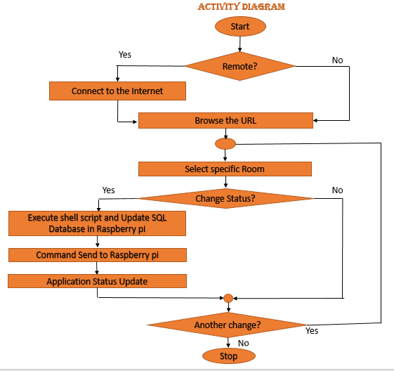

**Sequence Diagram: -**

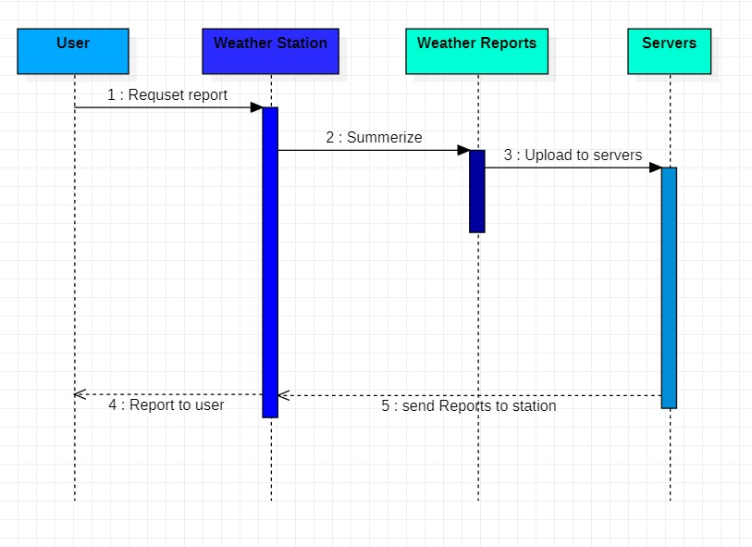

**Flow Diagram: -**

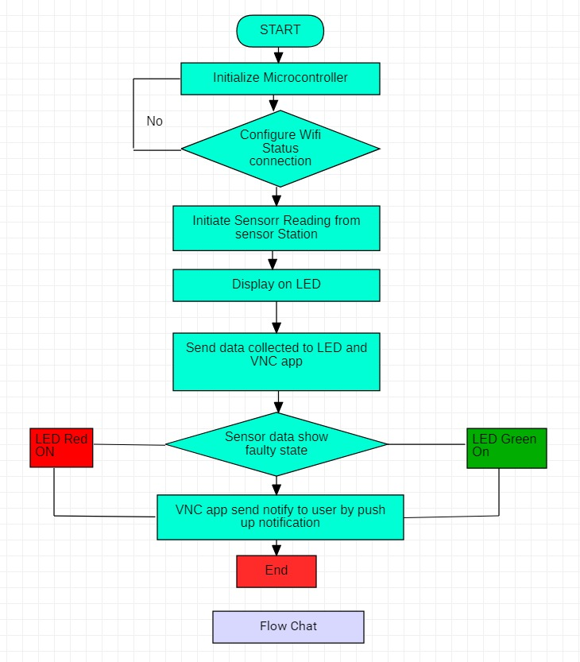

4.3 Procedural Design –

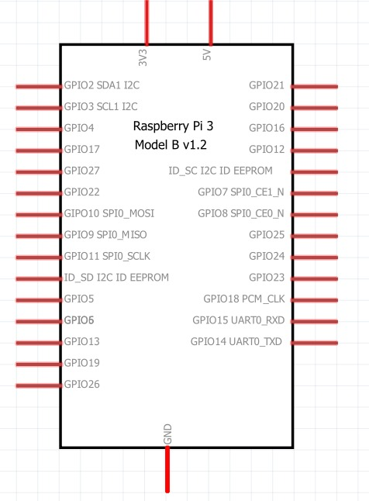

4.4 User interface Design –

**Use case Diagram: -**

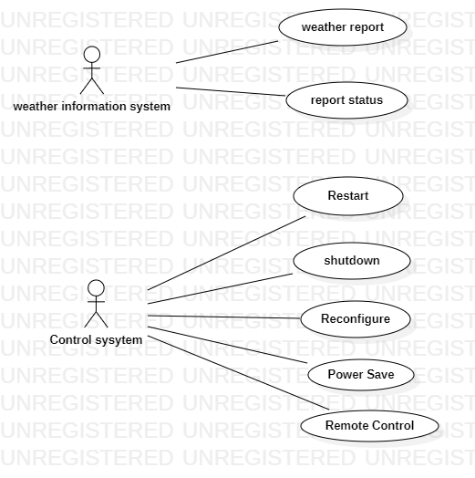

**Circuit Diagram: -**

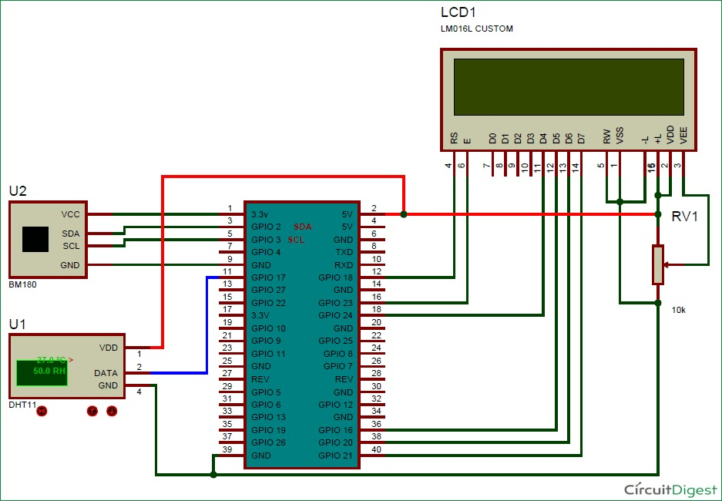

**Spiral –**

**Definition –**

The spiral model is a software development process combining element of both design and prototyping-in-stages, in an effort to combine advantages of top-down and bottom-up

concepts. Also known as the spiral lifecycle model (or spiral development), It is a systems development method (SDM) used in information technology (IT). This model of development combines

the features of the prototyping and the waterfall model. The spiral model is intended for large, expensive and complicated projects

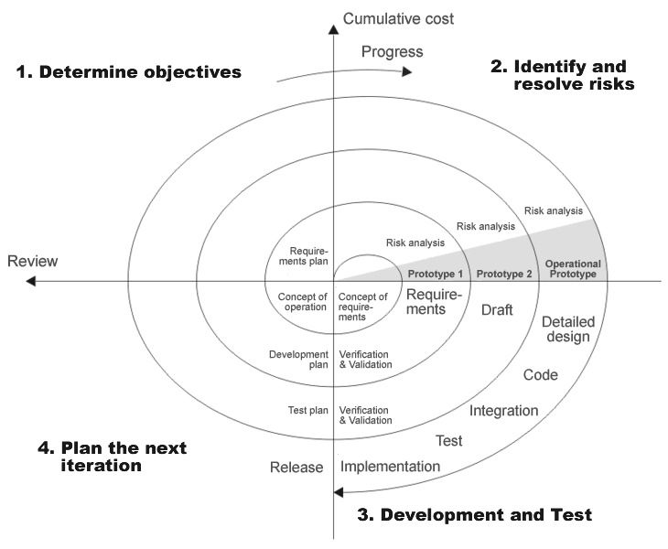

4.5 Test Cases Design –

* **For Node MCU: -**

|  |  |  |  |  |  |
| --- | --- | --- | --- | --- | --- |
| Test Case ID | Test Case Name | Test Case Description | Expected Output | Actual Output | Test Case status |
| No1 | Validate Voltage Intake | Checking for Voltage Intake | Should Consume 5V of current | The Consumption deviates by 0.2 | Pass |
| No2 | Validate working GPIO Pins | Checking for the GPIO. | Each GPIO pins should be respond as a code | Output as Desired | Pass |
| No3 | Validate the working of analog pins | Testing for analog pins | Using LDR for taking analog input | The analog input Various according to the Light | Pass |
| No4 | Verify the VCC Voltage from Node MCU | Checking for VCC and ground | These pins should give an 5V output and normal Ground | Gives the voltage with a fluctuation of 1.2V. | Failed |
| No5 | These pins should give an 3.3V Output | Checking for 3.3V Pins | These pins should give an 3.3Voutput | Gives the exact Voltage | Pass |

* **For Power Supply (Adapter):**

|  |  |  |  |  |  |
| --- | --- | --- | --- | --- | --- |
| Test Case ID | Test Case Name | Test Case Description | Expected Output | Actual Output | Test Case status |
| A01 | Validate Voltage Supply | The Voltage supply should meet the power Consumption different application | Should Provide the appropriate current in terms of Voltage and ampere | Provides the current as desired with a miner deviation of 0.2V |  |
| A02 | Checking the power supply from Node MCU | As some component powered by Node MCU it as to be Checked | A 5V and 3.3 V From the respective Pins | Output as Desired for 3.3V but fails for 5V |  |

|  |  |  |  |  |  |
| --- | --- | --- | --- | --- | --- |
| Test Case ID | Test Case Name | Test Case Description | Expected Output | Actual Output | Test Case status |
| L01 | Validate the working of LDR | The Code for taking analog input for LDR Runned on Node MCU and is tested for ambient light value With a Flash light | The analog reading value from LDR should Decrease with the deceasing light intensity | The reading value decreased with the decrease in light intensity | Pass |